-

10000 LIGHTS WOMEN EMPOWERMENT PROGRAM FOR GIRLS EXPOSED TO COMMERCIAL SEX EXPLOITATION AND TRAFFICKING

Submission Date: 4th.January,2024

Number: EP1001.2003

Period of reporting: 1st Jan ,2023

Prepared by: Achola Esther

Psychotherapist and Training Coordinator

Daughters of freedom/10000Lights Women’s Empowerment center

**ANNUAL REPORT**

**YEAR 2023**

Table of Contents

1. INTRODUCTION 3

2. PROGRAM ACTIVITIES 4

2.1. RESCUE OF VICTIMS EXPOSED TO CSE 4

2.2. REHABILITATION AND RECOVERY (WELLNESS) 4

2.2.1. Assessment 4

2.2.2. PTSD Recovery 5

2.2.3. Group Counselling Session 5

2.2.4. One on One Counselling Sessions 6

2.2.5. Medical Support 6

2.2.6. Family Planning Sessions 6

2.2.7. Life Skills Sessions and Personal Growth 6

2.3. REUNIOUN AND RECONCIALATION 7

2.4. REINTERGRATION 7

2.4.1. Vocational and Business Skills /Trainings 7

2.4.2. Home Visits 7

2.5. OTHER ACTIVITIES 8

2.5.1. International Women’s Day 8

2.5.2. Parents Meeting 8

2.5.3. Alumni Meeting 8

2.5.4. Staff Retreat 9

2.5.5. CSE Ally Training 9

2.5.6. Graduation 9

2.5.7. Christmas party and Alumni gathering 9

2.5.8. Staff EOY Team building event 9  EOY Fundraising 9

3. MANAGEMENT AND ADMINISTRATIVE ISSUES 10

3.1. MANAGEMENT ISSUES 10

3.1.1. Quarterly Meeting 10

3.1.2. Partnership Meetings 10

3.1.3. Registration with UCA 10

3.1.4. Signing of the MOU with KCCA 10

3.1.5. Board Meetings 11

3.2. ADMINISTRATION AND OPERATIONS 11

3.2.1. Procurement 11

3.2.2. Human Resource 11

3.2.3. Finance 11

4. FINANCIAL MANAGEMENT 11

5. STATISTICAL VISUALISATION AND CASE STUDIES 12

5.1. STATISTICALS 12

5.1.1. VSCE Actual recovery score board 12

5.2. CASE STUDIES 13

5.2.1. Case Study One: Of Ptsd Recovery Of Participant Ep/Hd/0103 13

5.2.2. Case Study Two: Of Ptsd Recovery Of Participant Ep/Fd/22/093 14

5.2.3. Case Study Three: Of Ptsd Recovery Of Participant Ep/Hd/0108 14

# INTRODUCTION

Commercial Sexual Exploitation of Children (CSE-T) thrives when perpetrators are not held to account. In Uganda, this lack of accountability can occur when criminal justice actors don’t have adequate technical capacity or resources. Capacity constraints paired with issues of corruption within the public institutions can result in low levels of trust between the community and criminal justice system. Consequently, community members are less likely to report trafficking cases to the police or other law enforcement organs at all. Survivors of CSE-T are extremely vulnerable to being trafficked. Therefore, reintegration programs for survivors must be carefully planned and tailored to the needs of each survivor so that they receive the necessary support to physically and mentally recover from their trauma and the resources, tools, and knowledge necessary for successful social and economic reintegration. This report provides an overview of program inventions and funded by Amilia’s Light USA to Daughters of Freedom Uganda.

112 victims and survivors of CSE rescued, rehabilitated and reintegrated since 2013

|  |  |  |
| --- | --- | --- |
| TOTAL OVER ALL ENROLLMENT STATISTICS FROM 2015-2023 | | |
| Particulars | Total numbers | %ge |
|  |  |  |
| Total no Enrolled | 112 |  |
| Total completed | 82 | 74% |
| Total exited | 30 | 26% |
| Total currently working | 80 | 98.2% |
| Total Not working | 2 | 1.8% |

10000 Lights Women Empowerment program is long term partners flagship program of Amilia’s Light USA and Daughters of Freedom Uganda (DOFU). Since 2013 Amilia’s Light has graciously supported restoration of 112 survivors of commercial sex exploitation and trafficking (CSE-T) by Rescuing, Rehabilitating, Reuniting and Reintegrating to the community. First with Destiney Women Uganda as a community based organization and currently with Daughters of Freedom Uganda as NGO Of the 112 enrolled, 74% (82) completed the program, 26% (30)[1] exited the program, 98.2% (80) are currently employed and self-sustained. 1.8% (2) are currently not working and relapsed. The girls were supported with evidence-based socio-economic interventions such as counselling, Intergroup Therapy[2], Life skills[3], Personal growth livelihood, vocational skills[4], family planning and self-protection skills[5].

# PROGRAM ACTIVITIES

## RESCUE OF VICTIMS EXPOSED TO COMMERICAL SEX EXPLOTATION & TRAFFICKING

During the period of reporting 86girls were identified, profiled and assessed for exposure to commercial sex exploitation. Of the total 86 assessed[6] 27.5% (22) were found eligible for the program with very severe (r=61-80) PTSD and enrolled into the program. The 22 participants were later screened for other auxiliary effects- 27.3% (6) were found with HIV[7], 45.5% (10) were found with other STIs[8] and 22,7% (5) were found with severe bruises and wounds being evidence to exposure and signs of CSE-T

100% victims and survivors of CSE rescued, were found with very severe (r=61-80) signs and symptoms of PTSD

## REHABILITATION AND RECOVERY (WELLNESS)

### Assessment

|  |  |  |
| --- | --- | --- |
| No | Description | Range/scale |
| 1 | Minimal | 0-10 |
| 2 | Mild | 11-20 |
| 3 | Moderate | 21-40 |
| 4 | Severe | 41-60 |
| 5 | Very Severe | 61-80 |

This report is extracted from an evidence base PTSD tool bench marked from USA National Center for PTSD (Post Traumatic Stress Disorder) CPSS-SR-5. It is a modified version of Child and Adolescent PTSD Symptom Scale self-report (CPSS-SR) for DSM-5 (Diagnostic and Statistical Manual of Mental). The 20 PTSD symptom items are rated on a 5-point scale of frequency and severity from 0 (Minimal) to 4 (very Severe). The 20 symptom items are used to calculate a total symptom severity score (0-80)[9]. A cut off score of 31 can be used for identifying a probable PTSD diagnosis in children and adolescents. In sum, the CPSSSR-5 is a valid, reliable self-report evidence-based instrument for assessing DSM-5 PTSD diagnosis and severity for children and adolescents

### PTSD Recovery

The graphical distribution shows the assessment of 18 particpates over a period of 12 months. The actual recovery (dots) is compared against the Standard recovery scale (line)

*85%* of the clients show positve and normal recovery trends

Generally, over 85% of the clients show positve and noraml recovery trends in 12months with 15% outlayer distrubtion. However the statistics shows nearly- 90% of the participants showed a slow rate of recovery against the standard recovery over a period of 12months . Follow-up evidence shows slow recovery trend is as a result of ; Limitted support from family,Continued negative peer influence of the participants while out the premises, Some of the the participants are still living with their abusers ( pimps) which imposes a critical challenge to the recovery treand of the vitims . As a result, the program through the works of the psychotherapist provided; Family counselling,Family reconcilliation meeting,Life skills sessions,Personal growth sessions and the Counseling sessions to improve the rate of recovery.

*100%* of the clients who completed the IPTG session report applying the knowledge gained from the session in their daily life

### Group Counselling Session

During the reporting period, Inter Personal Therapy for Group (IPTG) counseling sessions conducted, the program enrolled 18 participants for group counseling sessions. 100% completed the sessions. Of the total participants who completed the group counseling sessions, 94% (17) reported gained knowledge, 88% (15) reported applied the knowledge obtained and 100% reported the knowledge acquired having positive impact in their daily life decisions and choices.

### One on One Counselling Sessions

*85%* of the Survivors of CSE-T that completed individual counselling sessions show positve and normal recovery trends in 12months with 15%

In the reporting period, counseling sessions conducted, the program enrolled 22 participants for counseling (Participants-Survivors of Commercial Sex Exploitation and Trafficking). 82% (18) participants completed the sessions. And 18% (4) dropped out. over 85% (15) of the clients show positve and normal recovery trends in 12months with 15% outlayer distrubtion. However the statistics shows nearly- 90% of the participants showed a slow rate of recovery below the average standard recovery over a period of 12months and 100% reported the knowledge acquired having positive impact in their daily life decisions and choices.

### Medical Support

During the reporting period Survivor had medical screening. Of the total (18)[10] screened, 16.6% (3) were found HIV+[11], 55.5% (10)[12] were found with STIs and 27.7% (5) were found with wounds and injuries due to CSE-T. Of the total (18), *72.2% (13) were referred for medical treatment* and 76.9% (10) have fully recovered and 23.7% (3) are still under medical treatment due to chronic nature of the treatment. These 3 are on ART and other psychotherapies.

*72.2%* of the Survivor who were treated for various medical conditions have fully recovered

### Family Planning Sessions

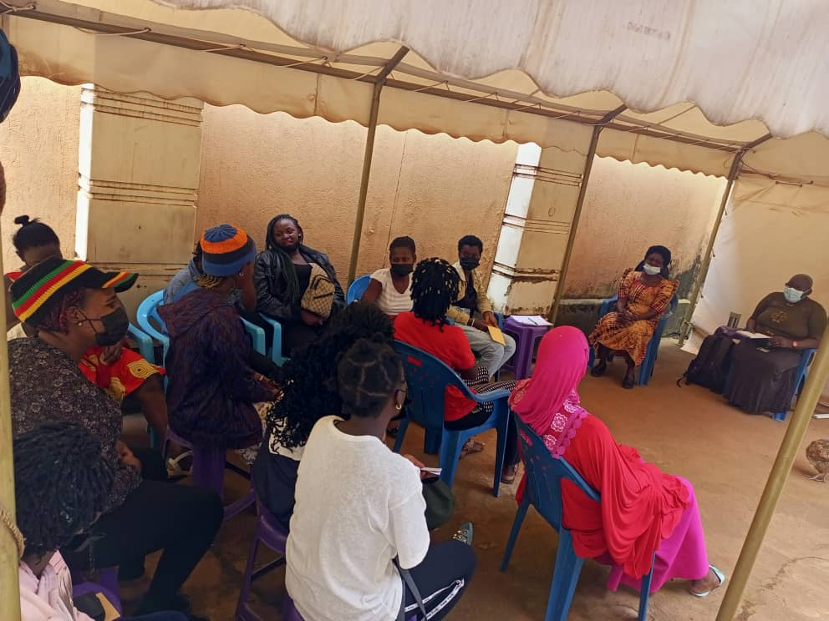A total of 18 (Survivors) were enrolled for family planning sessions in the reporting period. 100% completed the sessions. Of the total participants who completed the sessions, 55.5% (10) reported gained knowledge in better family planning methods, *44.4% (8) reported applied family planning methods of their choice* and 100% reported the knowledge acquired during family planning sessions is having positive impact in making better family planning decisions and choices.

### 

*94%* of the who completed lifeskills sessions applied the knowledge in making personal decisions and choices

### Life Skills Sessions and Personal Growth

During the reporting period, Survivors were enrolled for Life skills sessions[13]. 18 completed the sessions. Of the total who completed the life skills sessions, 18 reported gained knowledge, *94% (17) reported applied the knowledge obtained from life skills sessions in their daily life of making choices and decisions*. 100% (18) reported the knowledge acquired has positive impact in their daily life decisions and choices.

During the reporting period,18 survivors were enrolled for personal growth sessions. 100% completed the sessions. Of the total participants who completed personal growth sessions,55.5% (10) reported gained knowledge, 44.4% (8) reported applied the knowledge obtained and 100% reported the knowledge acquired having positive impact in their daily life decisions and choices.

## REUNION AND RECONCIALATION

*88.9%* of the survivors of CSE reunited to their families

In the reporting period, the families of the 18 participants were traced. of the total, 88.9% (16) participants were found in their families. 11.1% (2) were not. The psychotherapy department through Local Councils, Allies and Community Volunteer Counselors (CVCs) traced and found the two families. Of the 18 families found, all received counselling and reconciliation sessions. As result 18participated are fully reunited and reconciled to their families of origin.

## REINTERGRATION

### Vocational and Business Skills /Trainings

In the reporting period, 22 participants were enrolled to train in vocational, business skills and work ethics 86% (18) participants completed the training and were sent in for internship placements. The process involved offering internship placement letters and trainers helped the participants in the search for the placement. Of the total 18 were offered internship placements. Of the total that successfully completed their internship, 61% (11) were retained and offered permanent jobs, 16.7% (3) are volunteering 11.1% (2) plan to start own business and 11.1% (2) are still looking for jobs. Management is supporting the rest of the girls to get job placements.86% (18) of the participants enrolled for English lessons as a second lesson of the 18, 86% (18) participants completed.

*61%* of the trainees were retained and offered permanent jobs after internship

### Home Visits

During the reporting period, there were routine field visits and these included visiting participants from home and others at their workplaces. Of 112 beneficiaries 35.7% (40) were home visited, 26.7% (30) participants were followed up on phone. Of the total visited and contacted, 22.3% (25) Freedom girls are steadily married, 60.7% (68) freedom girls are working and 3.6% (4) are still struggling with unsustainable source of income and 26.8% (30) participants are lost to follow-up (LTF) are difficult to find. Management is working with Allies and Community Volunteer counselors to trace and follow-up and ascertain their resilience status.

*60.7%* of the reintegrated girls are employed and have means of livelihood

## OTHER ACTIVITIES

### International Women’s Day

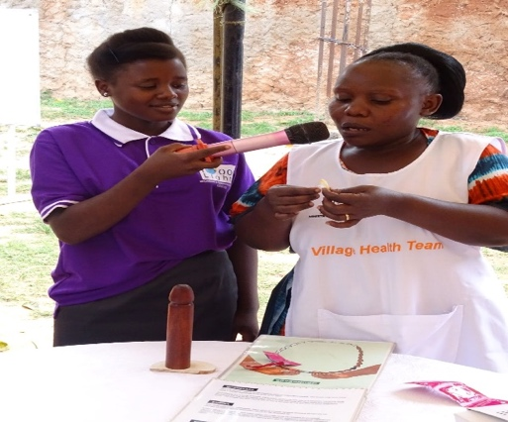International Women's Day is a global holiday celebrated annually on March 8 as a focal point in the women's rights movement, bringing attention to gender equality, reproductive rights, and violence and abuse against women. In this reporting period, 10000 Lights Women Empowerment Center choose to celebrate the day through organizing a whole day health awareness event as a way of giving back to the community by providing free health services and health talks. The event was also meant to create awareness about CSE-T and to make the community understand about our programs at the empowerment center.

Through the event ,10000 Lights Women Empowerment Center was able to connect with 6 organizations and partnered with them to ensure that the event was a success and the organizations included Baylor-Uganda, YITA Life, Reproductive Health, UCI, UTANO and UNCDA. The event benefited both the young and the old altogether 285 community members benefited in the health services,209 members were administered with deworming tablets which were provided by Yita Life nurse Namono Rose Diana, 38 Community members were screened on NCDs and those included Pressure and diabetes, 69 Community members were counseled and tested for HIV/AIDs and out of 69,5 tested positive and were referred to Baylor to start their ART treatment and care, 76 community members received Reproductive health services and family planning health talks. 15 members were referred to reproductive health Uganda to access the family planning services.

### Parents Meeting

## With the purpose for the organization and parents/caretakers to connect, management organized a parent’s/Caretakers meeting that was held at the 10000 Lights Women Empowerment Center Women’s Empowerment center premises in Mpererwe. Issues addressed included Internship, Graduation and general wellbeing of the participants.

During the reporting period, 6 parents attended the meeting. Only 2 parents/Caretakers didn’t turn up, we were able to receive positive comments and honest feedback from the parents

The meeting went on well and everything on the agenda was covered, Parents were able to interact with the staff and trainers and received important information from the staff and the Executive Director, Staff was able to meet the parents/Caretakers and got to know each other.

### Alumni Meeting

During the reporting period, Alumni meeting programs were conducted these are conducted every Quarter of the year in order to bring back all the participants together so that they can get to know each other.  The main reason for this particular meeting was to conduct a survey to get feedback from the Alumni in regards to program development.

### Staff Retreat

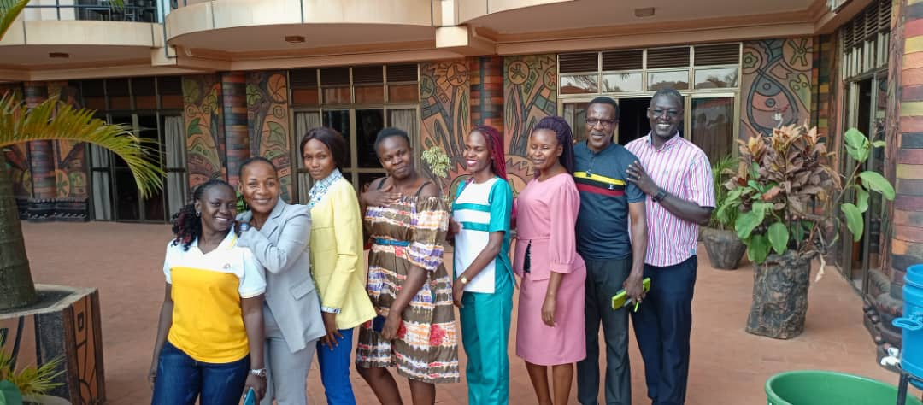 A staff retreat was held on the 14th/July/2023 at Tick Hotel in Kampala Kawempe Division and it was a full day event.  Staff  retreat was an opportunity for staff members to come together, away from the office and their typical responsibilities to a learning experience, Sharing ideas, Getting  to know and understand oneself better, Address and come up with solution for the organizations Challenges, Pray and share the word together, Listen from the Directors, Have fun together through the  team-building activities, It was downtime for informal socializing and collaborative work through sharing the departmental achievement , Brainstorming on the future and having a meal together as a team.

### CSE Ally Training

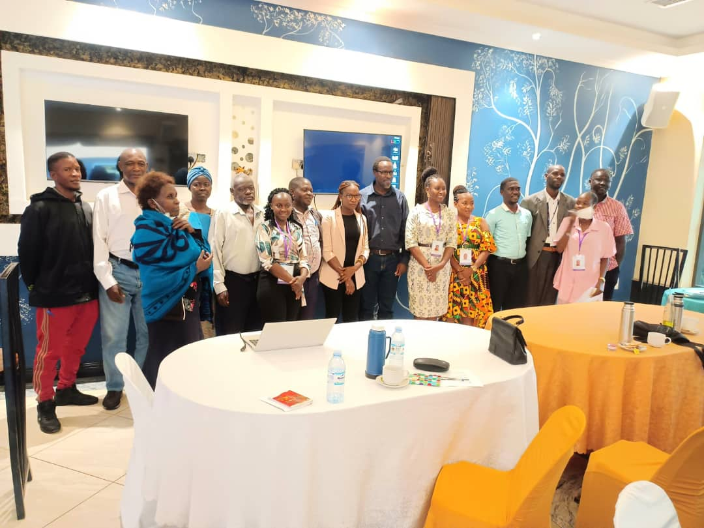 The second Ally CSE -T (commercial Sex exploitation and Trafficking) training was held with the purpose of equipping Ally with basic knowledge on CSE-T, identifying and dealing with victims of CSE-T. The training was held at Palm Gardens on 20th September, 2023. A total of 21 participated in the training. The training was attended by designated allies who included social workers, Doctors, Pastors, Local leaders and Government officials at KCCA govern levels including the CDO and the probation officer. The training was conducted by the daughters of freedom staff and directorate. With an objective to build the capacity of the designated Allies selected from different communities and offices.

The purpose of this training was to train participants on the basic knowledge of CSE-T, identifying, dealing and referring victims of CSE-T to the Empowerment center for the Programs. This was also meant to inform Allies about Daughters of freedom Uganda Mission, Vision, Goal and programs at 10000 Lights Women Empowerment Centre.

Training included various topics such as Program Description and organizational background, Introduction to CSE-T Selection Criteria, how to identify victims, Approaching victims, Role of Allies. The training was interactive as the trainers ensured that knowledge was not only disseminated but accurately perceived and understood by the participants. And in order to ensure this, trainers engaged participants in discussions and kept the forum open for feedback, queries and suggestions which were responded to by the organization management. These discussions and interactive sessions were supported through training PowerPoint presentations and handouts on participatory planning.

### Graduation

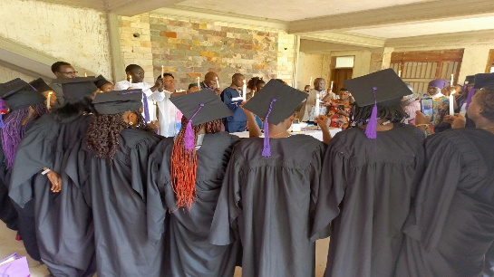During the reporting period, the 5th graduation ceremony was held at Wakiso DOFU headquarters. Of the 22,18 participants graduated, 10 from hair dressing section and 8 from the fashion and Design section. Certificates were awarded by the guest of honour and the Executive director. Graduates were also gifted with business start-up equipment’s (Flat Irons and Dyer for hair dressing class).Caregivers extended their gratitude to the organisation and Amilia’s Light and Daughters of Freedom for the Empowerment programs at 10000Lights Women’s Empowerment centre which have benefited the participants by equipping then with vocational knowledge as well as start equipment .

2.5.7. Christmas party and Alumni gathering 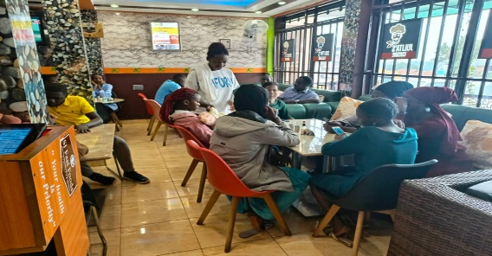

A Christmas party and Alumni 4th quarter gathering was held on the 15th/Dec/2023 at 10000 Lights Women’s Empowerment center premises in Kampala Kawempe Division and it was a full day event for all the graduating class to come together, share experience, Network and have fun together with the staff. The day was full of team building activities which were meant to bring all the graduate classes together and get to know each other better. As a result, the current graduate class 2023 were able to learn and get job opportunities from the alumni

2.5.8. Staff Team building Event

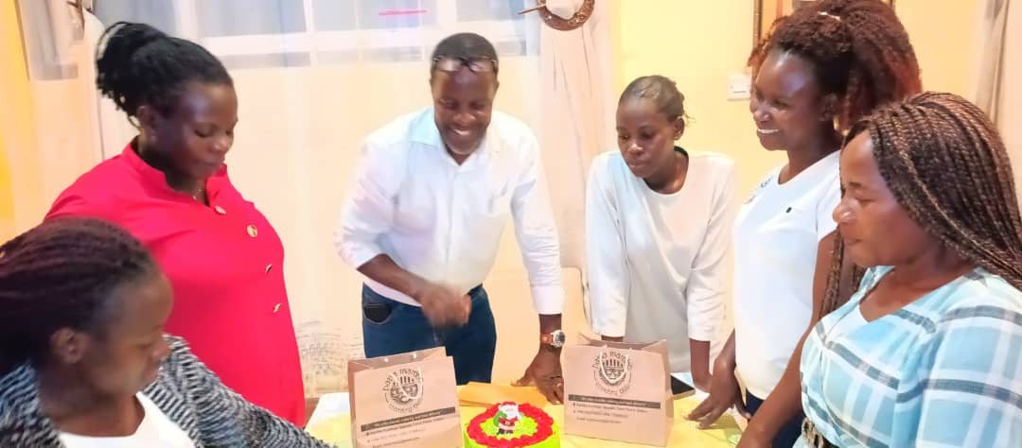The year 2023 was warped up with a staff end of year team building event. The event was held at Papa Mambo along Gayaza road. All staff were engaged in team building games that required them to practice team work. Staff then had a meal together with the executive director. The day was fun full day and staff had time to reflect on how the year has been. As a result, the staff were able to reconnect, reflect and remake as a team.

2.5.9. EOY FUNDRAISING

During the reporting period, all staff, Executive director and the AL President and Anna, were engaged in the end of year fundraising with the theme Healing, Transformation and Empowerment “Even a girls voice can be hard’ ’Videos were recorded and uploaded on the social media platforms for fundraising.

# 3. MANAGEMENT AND ADMINISTRATIVE ISSUES

## 3.1. MANAGEMENT ISSUES

### 3.1.1. Quarterly Meeting

During the reporting period, 4 quarterly meetings were held, Management and Staff meetings have been held on a weekly basis and Quarterly management review meetings held at the end of every quarter. For justifying the activity report for the quarter. All management issues during the quarter were resolved in the quarterly management meetings.

### 3.1.2. Partnership Meetings

During the reporting period, CSE trainings were conducted and 30 allies were trained on Identifying eligible participants as a result 86 participants were referred for the year 2023-2024.

### 3.1.3. Registration with UCA

During the reporting year DOFU sponsored the psychotherapist registration with Uganda Counseling Association and as the result the organization has illegally recognized psychotherapist by the counseling body. The psychotherapist was given an operating certificate and the UCA Identity card that shows that she is member operating under UCA.

### 3.1.4. Signing of the MOU with KCCA

In the reporting year KCCA (The Kampala City Council Authority) inspected and entered a Memorandum of understanding (MOU) with DOFU. As a result, Daughter ‘s of freedom is officiated by KCCA and has a good working relation with the KCCA body.

### 3.1.5. Board Meetings

The Board of Directors convenes quarterly according to the policy governing meetings of the organization and discuss pertinent issues of the organization on quarterly basis before Annual general meeting (AGM) which happens once every year.

## 3.2. ADMINISTRATION AND OPERATIONS

### 3.2.1. Procurement

During the reporting period, a computer policy was put in place as new camera, sewing machine and a new laptop for the training coordinator were purchased and an assets register was put in place.

### 3.2.2. Human Resource

The human resource team visited the center and evaluated the staff and established a human resource policy and procedures which included Staff movement and staff duty attendance books were introduced During the reporting period, new staff were hired, The Executive Director on management and an English Trainer on probation

### 3.2.3. Finance

During the reporting period, Wire transfers were made on a quarterly basis, and bank withdraws on a monthly basis. External audit for the year 2022 were conducted by JR & Associates certified public Accountants located at plot No, 70, Bukoto street. A new software (Manager) was put in place with the guidance of Mr. Fulukas Founder of Daughter Freedom to improve on the reporting and budgeting and this is will be functional effective 2024.

# FINANCIAL MANAGEMENT

|  |  |  |  |  |  |  |  |  |  |
| --- | --- | --- | --- | --- | --- | --- | --- | --- | --- |
| Activity Financial Analysis | | | | | | | | | |
|  |  |  |  |  |  |  | | | |
| Award Details: | |  |  |  |  |  | | | |
| a. Opening Balance 1st Jan 2023 | | |  |  | UGX. 4,238,690 | | | | |
| b. Total Obligated Amount (From AL) | | |  |  | UGX. 118,272,650 | | | | |
| c. Start/End Date new Fin Year | |  |  |  | 1st.January.2023 | | 23rd. December 2023 | | |
| d. Total Amount received | | |  |  | UGX. 11,997,000 | | | | |
| e. Total amount spent | | | | | UGX. 116,099,238 | | | | |
| f. Total Spent not billed | | | | | UGX. Nil | | | | |
|  |  |  |  |  |  |  | | | |
| g. Balance Carried forward | | | | | UGX. 8,952,490 | | | | |
|  |  |  |  |  |  |  | | | |
|  |  |  |  |  | Q1 | Q2 | | Q3 | Q4 |
| Actuals Received | | | | | UGX.30,470,000 | 30,720,000 | | 29,780,000 | 29,000,000 |
| Actuals l Spent | | | | | UGX. 24,394,402 | 29,217,043 | | 32,219,119 | 30,268,675 |
| Variance | | | | | 6,075,598 | 1,502,957 | | -2,439,119 | -1,268,675 |
| % Variance | | | | | 19.94% | 19.4% | | 0.8% | 4.2% |

Budget Notes:

The 32% budget deficit in Q3 results from over expenditures in the following budget lines: Staff Retreat, Internal Audit, Accounting fees, KCCA inspections, Exams, water repairs and communications and Airtime.

# STATISTICAL VISUALISATION AND CASE STUDIES

## STATISTICALS

### VSCE Actual recovery score board



The above PTSD recovery dashboard shows the monthly actual recovery scores for a period of 12months. This report is extracted from an evidence base PTSD tool for USA National Center for PTSD (Post Traumatic Stress Disorder) CPSS-SR-5. It is a modified version of Child and Adolescent PTSD Symptom Scale self-report (CPSS-SR) for DSM-5 (Diagnostic and Statistical Manual of Mental). The 20 PTSD symptom items are rated on a 5-point scale of frequency and severity from 0 (Minimal) to 4 (very Severe). The 20 symptom items are used to calculate a total symptom severity score (0-80)[14].

## CASE STUDIES

### Case Study One: Of Ptsd Recovery Of Participant Ep/HD/0103

The graph shows the level of recovery of participant EP/HD/0103 in a period of 12 months. The graph compares her Level of Depression (LoD) and Level of Recovery (LoR) against the Standard Rate of Recovery (SrT)

Cummulately, the graphical distrubtion shows a serever depression Level of about 80% from the month of November 2022 which is constant to the month of July 2023 and this is explained as a result of contionous GBV( Gender based violence) by the partner. In addition the Participant tested HIV postive and was in denial. She failed on her ART due to denial. She was in self deficit and was manifesting signs of schizophrenia and suicidal ideation. This called for urgent referral for clients to see a psychiatrist for further clinical intervention and treatment.

In the Month of August there is a relative recovery trend of 71% in Auguest and 52% in October compared to the standard recovery trend which was 35% in the month of October which shows a slight improvement and this is artibuted to the refferal made to the Healing talks counseling center for advanced counselling and IAC sessions that client underwent at Baylor College of medicine.

### Case Study Two: Of Ptsd Recovery Of Participant Ep/Fd/22/093

# 

The graph shows the level of recovery of participant EP/FD/22/093 in a period of 12 months. The graph compares her Level of Depression (LoD) and Level of Recovery (LoR) against the Standard Rate of Recovery (SrT) Generally, the graphical distrubtion shows solid evolution of 80% in the month of Novermber and Decemeber and deteriorated in the month of January at the rate of 0% recovery rate compared to the standard rate of recovery through the month of May to August with a serever depression Level of about 80% from the month of January and this is explained as a result of diagnosis for Abnormalities in the anatomic structure of the uterus, endometrial conditions. Fibroid tumors masses, cysts and tumors within the pelvis which was a result of deprived sexual behavior (CSE).

In the Month of September there is a relative recovery trend of 45% and this was artibuted to the family support support, Group and one on one counseling sessions held at the center as well as the support for medical assessment and treatment provided by 10000lights how ever she dropped again in the month of October due to the re traumatization and triggers . Participate is still under threapies and follow up.

### Case Study Three: Of Ptsd Recovery Of Participant Ep/Hd/0108

The graphical distrubtion shows the assessment of EP/HD/0108 for the period of 12 months .

The average recovery index is measred against the distrubtion of actual Average recovery against the standard recovery index(The dotted line) over the period of 12months.

Generally, the graphical distrubtion shows a normal and postive recovery trend in over 85% of the participate .This followup evidence shows that the quicken recovery trend is as a result of ; support from family,Continued life skills sessions, Group counselling sessions that were conducted through out the reporting period and the sessions played a vital role in the recovery process of the client .

* + 1. Case Study Four; Of Ptsd Recovery Of Participant Ep/Hd/0102

The graph shows the level of recovery of participant EP/FD/22/0102 in a period of 12 months. The graph compares her Level of Depression (LoD) and Level of Recovery (LoR) against the Standard Rate of Recovery (SrT)

Generally, the graphical distrubtion shows high level of depression of about 80% in the month of Novermber,December,January and deteriorating in the month of March and static in April,May June and June at 60% it continues to deteriorate in the month of July at 40% which shows a progressive recovery of the participate .This this was artibuted to the peer support , Group and one on one counseling sessions.

1. 30 participants dropped out and this is due to the long distance to the center, Relocation from the area, pregnancy within the program and some go back for formal education. Of the 30,2 exited because they went back for formal education with the scholarship from R3Known,10 exited due to the long distances and lack of transportation,4 due to pregnancy,2 due to learning disabilities,3 due to work to be able to sustain their house hold members,9 exited due to Covid 19 and 1 joined another vocational institute.
2. This was done using the IPG evidence-based curriculum which was test and implemented in Uganda by Word Vision, Strong Minds and Hope after Rape.
3. An evidence-based curriculum – Stepping stones was used
4. The girls were trained in fashion and Design and Hair Dressing
5. This was using NO MEANS NO evidence-based Curriculum implemented in Uganda by USAID
6. evidence base PTSD tool for National Center for PTSD (posttraumatic stress disorder) DSM-5 PCL-5. (Diagnostic and Statistical Manual of Mental) The CPSS-SR-5 is a modified version of Child PTSD Symptom Scale self-report (CPSS-SR) for DSM-5. The 20 PTSD symptom items are rated on a 5-point scale of frequency and severity from 0 (not at all) to 4 (6 or more times a week /severe). The 7 functioning items are rated on yes/no.
7. According to the recent UPHIA 2020 results, HIV prevalence among AGYW 15-24 years declined from 3.3% in 2016 (4) to 2.9% in 2020 (16). Similarly, the national trend of HIV prevalence has been reducing over the last decade
8.
9. The CPSS-SR-5 has excellent internal consistency for total symptom severity (Cronbach’s alpha = .924) and good test-retest reliability (r = .800). The CPSS-SR-5 also demonstrates convergent validity with CPSS-I-5 (r = .904), and discriminant validity with the Multidimensional Anxiety Scale (MASC) for Children and Child Depression Inventory (CDI)
10. *4 of the 22 girls dropped out due to lack of housing and pregnancy* 
11. *This is a very high perveance rate among the participants compared to the national perveance of the age cohort which 8.5% which is much higher in Kampala.* 
12.
13. *Life skills session were provided using the evidence based No means No and Stepping stones curriculum* 
14. The CPSS-SR-5 has excellent internal consistency for total symptom severity (Cronbach’s alpha = .924) and good test-retest reliability (r = .800). The CPSS-SR-5 also demonstrates convergent validity with CPSS-I-5 (r = .904), and discriminant validity with the Multidimensional Anxiety Scale (MASC) for Children and Child Depression Inventory (CDI)